Object Oriented Data Structures
(CS 2021)

LABORATORY MANUAL
BS-EE, Fall 2026

LAB 02

Fundamentals of Object-Oriented Programming II

_______________________________________ | __________ |  | ____
STUDENT NAME | ROLL NO |  | SEC
______________________________________
LAB ENGINEER'S SIGNATURE & DATE
Engr. Zulkaif Sajjad
MARKS AWARDED: /10
_____________________________________________________________
NATIONAL UNIVERSITY OF COMPUTER AND EMERGING SCIENCES (NUCES), ISLAMABAD

Prepared by: | Engr. Alina Gulzar | Version: | 1.0
Verified by: | Engr. Shahid Qureshi | Date last edited: | Aug 23, 2026

LAB OBJECTIVES
- To understand the concepts of Classes
- To understand the concepts of Classes relationships
Object Oriented Programming:I
nstead of having function-oriented programs i.e., getting data and performing functions with it, we have now data that knows how to manipulate itself. This way, now the programming is object-oriented. It means that our programs revolve around data and the objects. Therefore, it would be nice to have some building blocks for programs so that these can be combined to write a program. We have so far talked about simple variables like integer, double and char, followed by strings of characters and arrays of different data types. But now, in the form of an object, we have a block which knows itself about contents and the behavior.
Objects:
While engaged in the process of programming, we try to solve a real-world problem. The real world is not only of integers, floats, doubles and chars, but there are other things like cycles, cars, buildings, schools and people. We perceive all these things as objects. Each object has a behavior associated with it. Consider the example of a man who can talk, walk, sit and stand etc. Similarly, we can think of a vehicle that has many functions. These objects also have attributes. For example, a man has height, weight, color of eyes and hair and so on. These all are his attributes. His actions will be referred as functions or methods. This principle may be applicable to vehicles, aero planes and all other real-world things. An aero plane has attributes like its height, width, number of seats and number of engines etc. These are attributes called data members. Its actions include take off, flying and landing. These actions are its functions or methods.
Classes:
A class is a way of defining a user-defined data type. In a class, one may find data members and member functions that can manipulate that data.Class is very similar to the structures, except that we can now include also functions.

//Example: A Simple Class
class rectangle
{ // A simple class
int height ; //height
int width ; //and width are private data members of class
public :
void Display (); //member function of class
};

void rectangle:: Display () //definition of function Display occurs outside of class
{
cout << height <<endl ;
cout << width <<endl ;
}
void main ()
{
rectangle Obj;
Obj. Display ();
}

Association:

If two classes in a model need to communicate with each other, there must be a link between them, and that can be represented by an association. Association can be represented by a line between these classes.
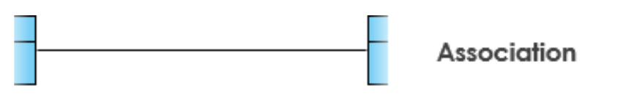

Most of the class relationships are actually associations, and following are few examples of those:
- Class Doctor and class Patient
The association between these two classes can be summarized as patient takes appointment from the doctor

- Class library book and class student
This relationship can be stated as student borrows the book

- Class hotel room and guest
Guest reserves a hotel room

- Class flight and passenger
Passenger reserves a seat on a flight

To develop the association relationship, a data member from either of the class is to be shared with the other class. For example

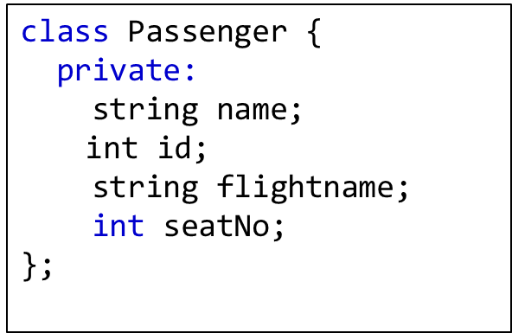
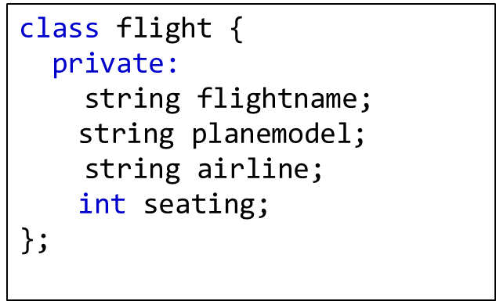
In the above example, which data member is being shared between the two associated classes?

Composition
Composition is the design technique in object-oriented programming to implement has-a relationship between objects.

To qualify as a composition, an object and a part must have the following relationship:
- The part(member) is part of the object (class)
- The part (member) can only belong to one object (class) at a time.
- The part (member) has its existence managed by the object (class).
- The part (member) does not know about the existence of the object (class).

A good real-life example of a composition is the relationship between a person’s body and a heart.

Example:

#include <iostream>
using namespace std;

class Engine {
private:
int horsepower;
float displacement;
public:
Engine(int hp, float disp) : horsepower(hp), displacement(disp) {}
int getHorsepower()
{ return horsepower; }
float getDisplacement()
{ return displacement; }
void start()
{ cout << "Engine started" << endl; }
void stop()
{ cout << "Engine stopped" << endl; }
};

class Car {
private:
Engine engine;
string model;
public:
Car(int hp, float disp, string mdl) : engine(hp, disp), model(mdl) {}
void start()
{
Cout<<”car start”<<endl;
engine.start(); }
void stop()
{ engine.stop(); }
void displayInfo()
{
cout << "Model: " << model << ", Horsepower: " << engine.getHorsepower() << ", Displacement: " << engine.getDisplacement() << " liters" << endl;
}
};

int main() {
Car car(200, 3.5, "Toyota Camry");
car.start(); // will call engine.start()
car.displayInfo(); // will display car information
car.stop(); // will call engine.stop()
return 0;
}

LAB TASKS:

Lab Tasks:
1. Create two classes, Book and Student, as shown below. Both classes are associated with each other and share the book_ID information between them. Create functions in these classes as per the requirements.
[Note: Each row in Fast_student.txt represents a single book issuance record. Therefore, the same student (same roll number) may appear multiple times if they have issued more than one book. Also, assume that the library contains multiple copies of each book, so the same book_ID may be issued to multiple students.]

class Book
{
private:
int book_ID;
string author;
string bookTitle;
public:
Book(int, string, string); //constructor
// other functions
};

class Student
{
private:
string studentName;
int rollNo;
int book_ID;

public:
Student(string, int, int); //constructor
// other functions
};

In the main function, store the information of books and students from file “Books.txt” and “Fast_student.txt”. Create object arrays of Book and Student classes and store data inside them.

Task 02:
Take input an author's name, and print all the names of students who have issued books by that author.

Task 03:
Take input a roll number, and print all books issued by that student along with their author names.

Task 04:
Now upgrade the student class using composition with class Address. For this purpose, the student class must contain an Address object as a data member.

class Address {
private:
int houseNo;
int streetNo;
string city;

public:
Address(int, int, string);
//other Functions..
};

- Read student records from students_updated.txt and store them in an array of Student objects.
- Take input a city name and print the list of students who belong to that city, along with their complete address.

